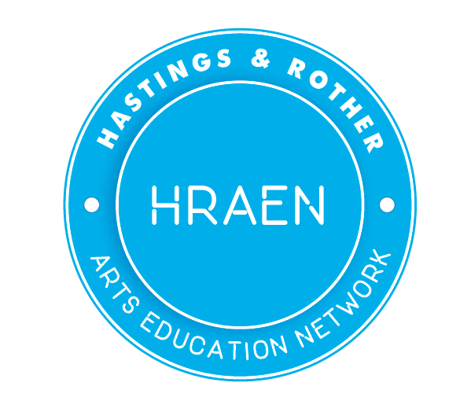
The Hastings & Rother Arts Education Network (HRAEN)
Annual Report 2018-19
Charity Number: 1179740
Trustees:
- Michael Hambridge
- Rebecca Reed
- Melanie Powell
Address:
HRAEN
PO Box 193
4 High Street
TN33 3EY
The objectives of the CIO as laid out in the governing document are:
1. To work with children, young people, artists, cultural and educational organisations to strengthen links between great cultural provision and learning opportunities.
2. To advance the knowledge, skills, confidence and capabilities of children and young people helping them to grow into active, culturally engaged citizens.
3. To develop children and young people’s mental, physical and moral wellbeing through arts and culture.
4. To increase opportunities for all children and young people in Hastings, Rother and the surrounding area to participate fully in arts and culture.
5. To ensure a strong commitment to equality, inclusion and diversity is embedded throughout our practices and programmes.

In 2018 19 HRAEN has;
- Run 3 x Networking sessions for teachers, artists and cultural organisations. Maintained the www.hraen.co.uk website. Managed social media sites @HRAENetwork. Distributed 3 newsletters to schools. Representation by steering group members on local partnership groups including the Hastings & Rother Cultural Leaders Group.

- Steering group members have presented the work of HRAEN at both Hastings and Rother Education Improvement Partnerships and have increased the number of schools working directly with the network.

- Reported back the work of HRAEN to the Hastings & Rother Cultural Education Partnership (CEP role undertaken through Culture East Sussex) with 2 presentations and regular report updates. Strengthening the link between the network and the CEP.

- Developed a 5 year business and funding plan to take the organisation forward. See Appendix 1

- Has worked alongside the Hastings and Rother Clinical Commissioning Group (CCG) Reducing Health Inequalities Grant Funding programme supported by additional investment from Artswork in support of Arts Council England’s Cultural Education Challenge. HRAEN worked with 7 cultural projects that delivered on the following outcomes:
  - 1. Encourage and support people to make healthier lifestyle choices
  - 2. Help people look after their own health better
  - 3. Improve access to local healthcare and/or other support services that will benefit health
  - 4. Address the wider social determinants of health
  - 5. Ensure more children and young people have access to and benefit from high quality Cultural Education by achieving Arts Award
  - 6. Ensure more settings, where eligible, achieve Artsmark
The fund targeted the most disadvantaged and marginalised communities in Hastings and Rother and was part of work to transform health and social care outcomes for local people through East Sussex Better Together (ESBT). In particular the grants contributed to work to grow strong communities, particularly the personal and community resilience work stream.

- Has worked with Rother District Council to secure funding from Artswork to develop the Schools Connect: Shakespeare in Schools project.
Schools Connect is a two year project starting in 2019 and finishing in July 2020 combining 5 strands of activity which feed each other to bring about a stronger more effective network. We will work closely with a core group of project schools so that these will become HRAEN Champion schools by the end of the project, and go on to lead a drive to engage more schools in the Champion network. The project has 5 key strands of work:
- Objective 1: Development of closer working relationships with schools
- Objective 2: Development of ArtsMark in schools in Hastings and Rother.
- Objective 3: Development of a Shakespeare in schools programme.
- Objective 4: Career Pathways
- Objective 5: Comprehensive Evaluation

- Has worked with Dens and Signals to develop the Animals Project which had its pilot phase in 2018 19.
The State of Nature report shows that over half (56%) of UK species assessed have declined since 1970, and 15% of species in Great Britain are thought to be extinct or threatened with extinction. Children (and particularly those from more deprived areas) spend little time outdoors and are often unfamiliar with even the most common wild species. They are particularly disengaged with and unaware of their own impact on even their immediate environment. This activity seeks to engage children and their families from the areas of highest deprivation in Hastings and Rother with issues concerning their local environment. We will do this by working with Hastings based theatre company Dens and Signals and 5 schools to provide a high quality arts experience that inspires and empowers.

- Has worked with Hastings Borough Council and Hofesh Shechter Dance Company to submit a bid through HSC to the Hastings Opportunity Area for a summer term programme of dance and Continuing Professional Development for secondary school students and teachers, with augmented funding from ESAP so as to include Rother schools.

- Is working with Out of The Bag Theatre to bring Speech Bubbles to the HRAEN area.
Speech Bubbles is a creative intervention using drama to support 5-7 year olds with Speech, Language and Communication Needs (SLCN) to develop their communication skills, confidence and wellbeing.
In Speech Bubbles sessions drama practitioners and school staff create a safe and playful space for children in KS1 to develop their communication skills. A story drama approach places the child at the centre of the activity, and they become at different times, author, performer and audience. A recent evaluation revealed that 85% of children participating in Speech Bubbles showed an improvement in learning, speaking and listening and 86% showed behavioural improvements.
Speech Bubbles is a social franchise established ten years ago by London Bubble Theatre. Out of the Bag Theatre with HRAEN are setting-up a social franchise to bring Speech Bubbles to primary schools in the Hastings and Rother area.
Financial Report for 2018-19:
HRAEN received no direct income in the financial year 2018-19.
HRAEN have employed an accountant to oversee financial management of the CIO.

