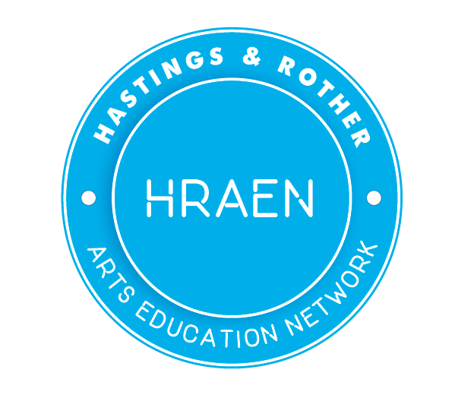
Newsletter January 2018
www.hraen.co.uk

Happy New Year to you all from HRAEN

Next Network Meeting: Tuesday 30th January
The next HRAEN meeting will take place on Tuesday 30th January at Bexhill College from 4-6.00pm.
The meeting will have a Health and Wellbeing focus with Stephen Calladine Evans of Fulcrum Learning presenting the findings of the Health and Wellbeing report, copies of which will be available on the day.
Head teacher Becky Reed from Chantry Primary School will talk about her school’s Artsmark journey, what that entailed and why you should think about taking the plunge.
Artist Lee Shearman will run a practical journal making session for teachers to take back to the classroom, materials will be provided.
There will be a separate breakout session for CCG funded project leaders to meet and discuss their projects, share ideas and highlight any support they might need.
We will again run a TeachMeet session, and we encourage teachers to bring along examples of things that have worked well in the classroom to share with other teachers and creative practitioners. 5min slots will be available on the day. For the lowdown on Teachmeet from Teacher Toolkit www.teachertoolkit.co.uk/category/teachmeets
And of course time for chat and meeting people and cake. Please let us know if you’ll be joining us - email melanie.powell@rother.gov.uk
Teacher CPD and school development
ARTSMARK – AUTUMN AND SPRING TERMS 2017/18
Schools in East Sussex have an incredible reputation for creativity and the relaunched Artsmark award is a great opportunity to demonstrate and recognise this in your setting. Awarded by Arts Council England, the new Artsmark award helps schools to deliver a high quality arts and cultural education.
For more information please go to: www.artsmark.org.uk
Artsmark Development Days Autumn and Spring Terms 2017/18
- Wednesday 24th January 2018 Brighton, Lighthouse
- Wednesday 21st March Brighton, Lighthouse
The standard Artsmark package costs £500 (unless you are a small school with less than 100 pupils, which attracts a 50% discount).

CREATIVE BOOST project CPD event for teachers
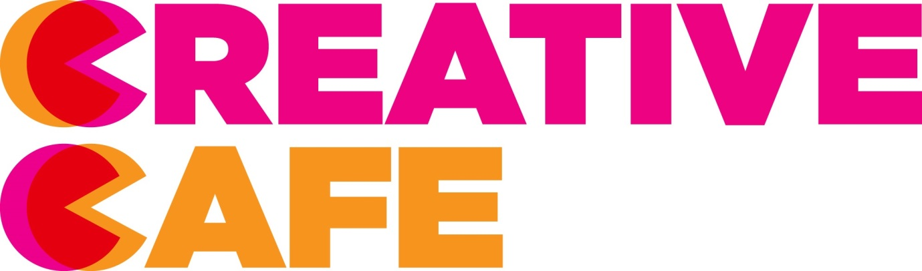
Thursday January 25 2.00-4.30pm De La Warr Pavilion
Creative Boost is a Skills East Sussex project designed to improve links between students and teachers in secondary schools and those working in the Arts and Creative Industries. All secondary teachers in the HRAEN network are welcome at this first CPD event. It will take the form of a Creative Café and give teachers the chance to meet creative professionals working across the creative industries. It’s a chance to update your knowledge about working in the sector and to reflect on how creative thinking and practice can be applied across the curriculum. Here’s some feedback from teachers at a similar event in Brighton.
http://artatwork.org.uk/projects/teachers-creative-cafes/ . The Creative Café is run by Culture Shift
To book a place email creativeboost@eastsussex.gov.uk or call Kimberley Bulgin on 01273 335625

Opportunities
£500 for Greening Grey Britain
The RHS is continuing to connect experienced community gardeners with young green thumbs in 2018 as part of Greening Grey Britain. They're offering hands-on support plus up to £500 worth of plants and materials to approved projects, which must be must be partnership based and intergenerational. For more information go to: https://www.rhs.org.uk/communities
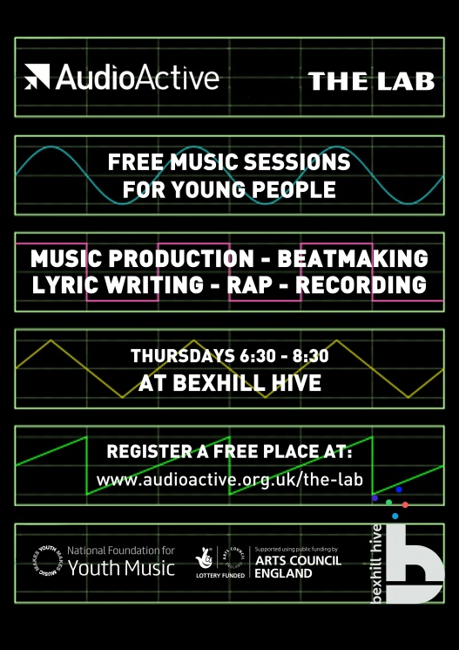
AudioActive's 'The Lab' now in Bexhill
AudioActive's 'The Lab' is a FREE music production and lyric writing project for young people run by professional artists specialising in tech and urban art forms. Taking place on Thursdays 6:30 - 8:30 at The Hive in Bexhill, the sessions are suitable for both beginners and experienced young musicians that want to experiment and collaborate. The project is run by legendary DJ/producer Skitz and lyricist Jon Clark. A previous incarnation of the project in Rye created an album to critical acclaim, played a show with BBC Introducing and performed at festivals across Sussex.
For more information contact info@audioactive.org.uk or sign up for a free place at
http://audioactive.org.uk/the-lab/

National Youth Theatre Workshop De La Warr Pavilion
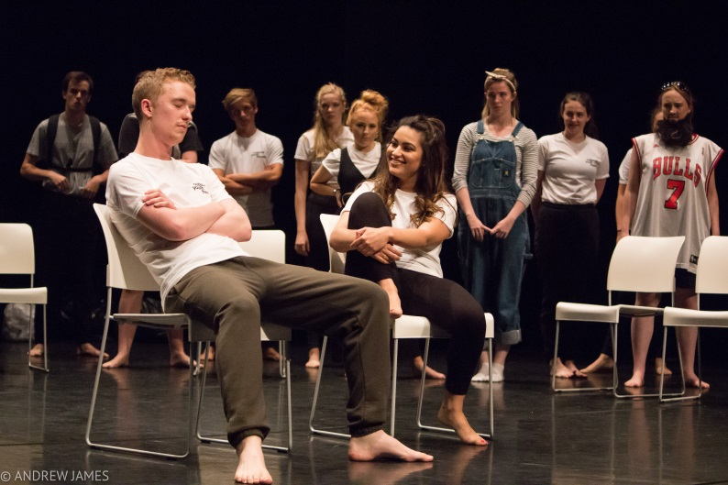
Thursday 15 February 11am – 1pm
For 14 - 25 years
FREE Spaces are limited and booking is essential
This introductory workshop in ensemble theatre and Q&A session is the perfect opportunity to gain a fun and informal insight into theatre making and demystify the National Youth Theatre ’s auditioning process. Auditions will take place at the De La Warr Pavilion on 24 March. Led by a professional theatre director. No experience required. Contact grace.clements@dlwp.com to find out more
For additional creative learning opportunities see https://www.dlwp.com/learning/schools/
Music & Drama Education Expo
Music & Drama Education Expo, Europe’s largest conference and exhibition for anyone involved in music & drama education, will be back 22-23 February 2018! Follow us on Facebook or Twitter to stay up-to-date with the latest news.
http://musicanddramaeducationexpo.co.uk/london/
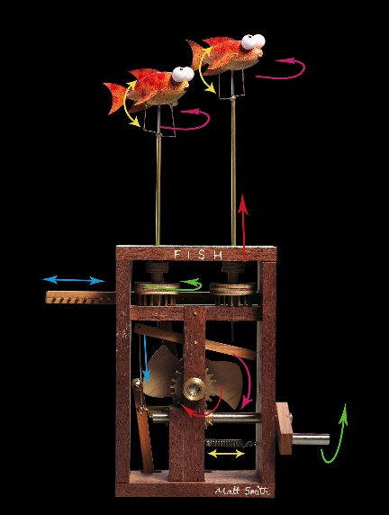
Automata on the Pier with Cabaret Mechanical Theatre
15th March-15th April 2018
Open Daily 10-5pm (admission free)
This exciting project sees Hastings Pier Charity working with Culture Shift and Cabaret Mechanical Theatre Collection to realise an ambitious exhibition of twenty and twenty first century automata on the Pier.
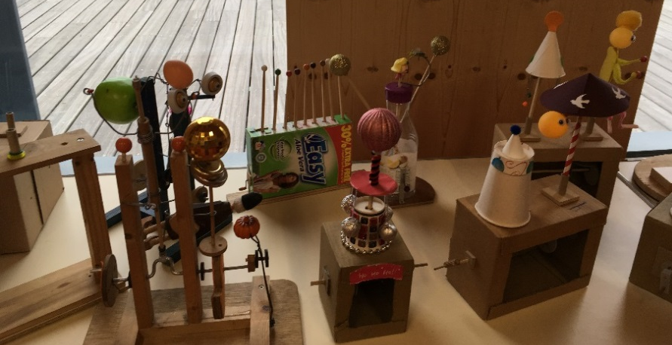
The exhibition will feature work by renowned artists as well as artworks created by members of the Craftivist Network. The Craftivist Network is an umbrella organisation which supports local organisations supporting vulnerable adults.

HPC Learning and Education department will engage schools and families in this community project and exhibition through a series of interactive workshops and events.

School Workshops-Week commencing 19th March:
For further information about booking a workshop please contact the HPC Learning Team;
Learning and Education Manager susan.kent@hpcharity.co.uk
Learning and Education Assistant francesca.piacentini@hpcharity.co.uk or call 01424 44556.

The Reading Hack Call for Ideas is open!
Reading Hack is looking for six groups of young people (aged 13-24) to come up with a project or idea that will encourage other young people to read more.
The solution can be anything that your group believe will encourage more young people to enjoy reading, or will make reading more accessible. It could be an event, a short film, a volunteering opportunity, an anthology or something else entirely. We’re looking for something exciting and fun that will appeal to those who don’t usually describe themselves as readers.
The deadline for ideas is Monday 29th January 2018. A panel of young people will then review all the applications and choose six groups to receive up to £500. These groups will then have until Friday 1st June 2018 to complete or carry out their idea.
http://readinghack.org.uk/blog/the-reading-hack-call-for-ideas

