HRAEN Latest

Dates for your diary:

* The next HRAEN Network meeting 4th July 2017 4-6pm, details to follow.

Hastings and Rother Music Month

St Patricks Day marked the end of our first Music Month and many thanks to all of you who took part.

We saw many of you at our consultation meetings at which numerous issues about music education, progression, career development were discussed alongside bigger infrastructure issues such as transport and venues. All this discussion has been captured and will form the basis of the Music Advisory Group focus. We hope music month and the bigger music cities project will bring music to the forefront of public thinking.

For more information on Music Cities please see [www.ifpi.org/downloads/The-Mastering-of-a-Music-City.pdf](http://www.ifpi.org/downloads/The-Mastering-of-a-Music-City.pdf)

HRAEN and the Cultural Education Partnership

HRAEN is now one of 2 official subgroups of the Hastings & Rother CEP and will lead on a stand of work encompassing wellbeing and culture . To better understand the CEPs I include this from Arts Council England:

*Through the Cultural Education Challenge, we want to make sure that more children and young people can create, compose, and perform. We want every child to have the chance to visit, experience and participate in extraordinary work, and be able to know more, understand more, and review the experiences they’ve had.*

*The Cultural Education Challenge asks art and cultural organisations, educational institutions and local authorities to come together to drive a joined-up art and cultural offer locally, to share resources and bring about a more coherent and visible delivery of cultural education through* [*Cultural Education Partnerships*](http://www.artscouncil.org.uk/children-and-young-people/working-partnership)*. The Arts Council aims to establish Cultural Education Partnerships across the country in places where there is most need.*

*A network of 10*[*Bridge Organisations*](http://www.artscouncil.org.uk/children-and-young-people/bridge-organisations) *located across the country will take forward these partnerships.*

*We launched the Cultural Education Challenge in October 2015, and you can watch a short film explaining the aims of the Challenge at:* [*http://www.artscouncil.org.uk/children-and-young-people/cultural-education-challenge*](http://www.artscouncil.org.uk/children-and-young-people/cultural-education-challenge)

Events & Opportunities

Youth Theatre Opportunity - Streets of Battle

Know someone aged 7-11 who loves performing? Streets of Battle Festival is running a three month youth performance project, supported by the Arts Council. 'Battle Youth Street Theatre' will develop a walkabout performance which young street artists will perform at Streets of Battle Festival in April and May, alongside some of the UK's top street acts. The group will be mentored by professional local theatre group 'Inside Out'.

No experience is necessary, taking part is totally free. All that's needed is to attend a rehearsal every Tuesday from 4.30-6.30pm in Battle. The first rehearsal is next Tuesday 21 March at the Almonry in Battle, but don't worry if you've missed the first one - it's not too late to join!

If you are interested or would like to find out more, please contact [insideouttheatre@live.com](mailto:insideouttheatre@live.com)

Find out more at [www.facebook.com/battlestreetart](http://www.facebook.com/battlestreetart)

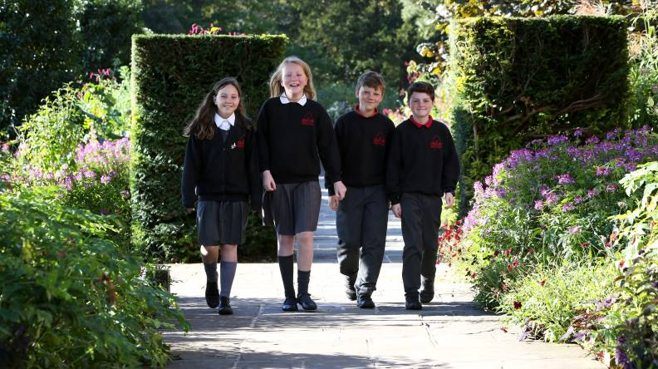

Glyndebourne Performance for Schools 2017:

These performances are a unique experience – Glyndebourne’s world-famous auditorium filled entirely with students, a special introduction on stage, and then all the emotion, spectacle and intensity of a Glyndebourne opera, full-length and fully staged.

In 2017 Performance for Schools include *Così fan tutte* and *Belongings,* a world premiere from Glyndebourne's Young Composer-in-Residence and performed by Glyndebourne Youth Opera.

* Mozart’s *Così fan tutte*on Wednesday 11 October 2017, 11.00am – 2.15pm at Glyndebourne.  
  The opera is recommended for Year 7 upwards (aged 13 and above) and tickets are only £7 per student.
* Lewis Murphy’s *Belongings* on Friday 10 November 2017, 1.00pm – 2.00pm at Glyndebourne.  
  This opera is recommended for Year 5 and up (aged 9 and above) and tickets are £5 per student.

Free educational resources

* Online Guides and teaching resources for English, Music and Art & Design teachers, available from September 2017
* An on-stage introduction for schools before the performance
* Programmes for students to take home
* A poster for the classroom

Eligibility: We accept applications from groups in full time education based within 25 miles of Glyndebourne.

How to book

If you are not currently on our mailing list [sign up](https://docs.google.com/a/glyndebourne.com/forms/d/e/1FAIpQLScO85Cd1atIj5MkCsZW1vysdHMKP8fMLk15xuqle8BvaqtbWQ/viewform) to receive our brochures. Given the high demand for these performances, tickets are allocated by ballot. To enter simply complete the by Friday 12 May 2017.

<http://glyndebourne.com/education/take-part/schools/performances-for-schools>

[Glyndebourne Youth Opera](http://www.glyndebourne.com/education/take-part/young-talent-ages-9-30/glyndebourne-youth-opera/gyo-workshops-2/)

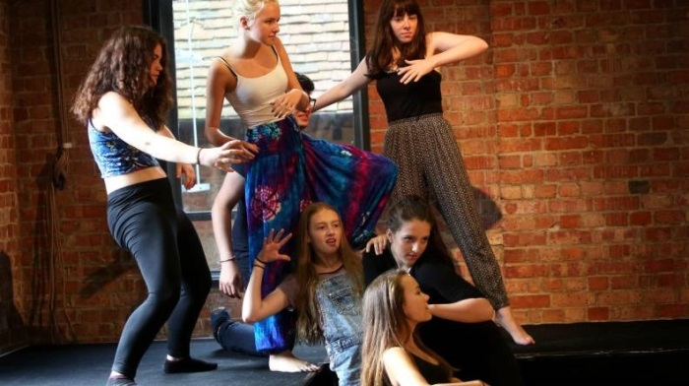[Glyndebourne Youth Opera](http://www.glyndebourne.com/education/take-part/young-talent-ages-9-30/glyndebourne-youth-opera/gyo-workshops-2/) are holding 2-day workshops for 9 - 19 year olds living in the local area during the Easter holidays. These provide participants with the chance to explore some of the different artistic disciplines involved in making opera (including singing, drama, design and language) in a fun and creative way.

**Monday 3 and Tuesday 4 April** (10.00am to 4.00pm)

Ark William Parker Academy, Parkstone Rd, Hastings

Workshops will be led by renowned music director Stephen Higgins with input from an exciting team of opera professionals, including language coach Isabella Radcliffe, director James Bonas in Hastings and choreographer/director Denni Sayers in Brighton.

The cost of taking part is £34 for 2 days (concessionary rates available). To find out more and for eligibility details and please visit the website [www.glyndebourne.com/education](http://www.glyndebourne.com/education) or to book, call the Box Office on 01273 815 000.



CPD & Training

## FREE CPD THIS SUMMER

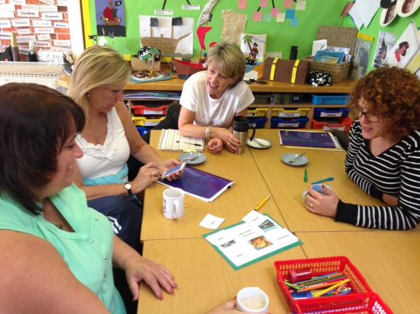Get £500 e-credits for free CPD

Sign up to the Global Learning Programme (courses to be booked by June).

Your school will get £500 ecredits which you can spend on training your staff to embed global learning into the curriculum.

£500 e-credits will pay for ‘Whole School’ training.

OFSTED look favourably on schools taking a whole school approach to global citizenship!

Find out more at [18hours.org.uk](http://18hours.org.uk)

Arts Award Training

Culture Shift is this region’s Arts Award training agency. We train people to be advisers to support children and young people through Arts Award. Training sessions provide:

* an overview of the ethos and spirit of Arts Award and a chance to explore case studies and examples of work
* a chance to meet other professionals who are planning to run Arts Award in a wide variety of settings
* become familiar with the assessment criteria and framework for each level
* ask questions about how Arts Award may work for you in your particular setting

All our public courses are delivered at Lighthouse in Brighton. See list of dates below and links to more information.  The cost is £140 for Discover and Explore and £190 for Bronze and Silver.

Arts Award Discover and Explore 7 April 1.30-5.00pm : <http://www.cultureshift.org.uk/events-and-training/de7april/>

Arts Award Bronze and Silver 18 May 10.00am-5.00pm: <http://www.cultureshift.org.uk/events-and-training/bs18may/>

Arts Award Discover and Explore 22 June 1.30-5.00pm: <http://www.cultureshift.org.uk/events-and-training/de22june/>

Arts Award Bronze and Silver 22 July 10.00am-5.00pm : <http://www.cultureshift.org.uk/events-and-training/bs22july/>

If you have a group of 6 or more you can opt for in house training, with the training delivered in your setting, at a lower per head cost.

For more information email [catherine@cultureshift.org.uk](mailto:catherine@cultureshift.org.uk)

**Ian Murphy**

CPD Art Teacher Workshops

Saturday 27th May 2017

St Richard’s Catholic College, Bexhill-on-Sea

*I am absolutely delighted that we are hosting this event. Ian Murphy is an incredible artist and recommended on the AQA Art exam question this year as an artist that pupils may choose to study. The new art specification which starts next year has a strong emphasis on drawing as a key part of the coursework and this workshop will be a wonderful opportunity for any art teacher teaching GCSE and KS3 curriculum.*

Miranda Pennington; Art teacher St Richards CC

For more information and to sign up please go to:

<http://www.ianmurphyartist.com/cpd-drawing/>

|  |  |  |  |  |  |  |
| --- | --- | --- | --- | --- | --- | --- |
|  | Picture | Picture |  | Picture | Picture |  |