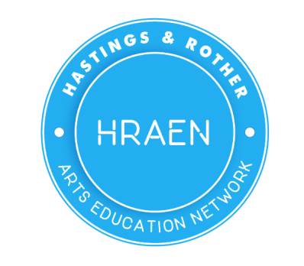
Hastings & Rother Arts Education Network Newsletter
www.hraen.co.uk May 2018
HRAEN News
Next Network Meeting:
3rd July 2018 4-6pm at Hastings Museum and Art Gallery
Join us to network with artists and education officers from a variety of cultural organisations in Hastings and Rother to start conversations or swap ideas about how we can best support each other in delivering outstanding cultural learning experiences in class.
To book a place simply let us know you are coming with an email to: melanie.powell@rother.gov.uk
HRAEN Health & Wellbeing report
Following the publication of our Health and Wellbeing report, HRAEN are now focusing attention on project delivery though the accompanying action plan. The plan respects the fact that the proposed actions are part of a competing set of priorities for schools and their leadership. The plan intends to build a platform of best practice that is reinforced by practitioner research, in a manner that assists in drawing down external sources of financial support, thereby securing a sustainable programme for the benefit of our young people.
The report commissioned by HRAEN to look at issues relating to health and wellbeing in school and the use of culture as a tool to address these issues, has been released and can be downloaded from the HRAEN website www.hraen.co.uk . HRAEN are now looking to work with a core group of schools interested in developing this work further. If your school is interested in having a conversation about this are please get in touch.
The Cultural Learning Alliance with Place2B have also released their briefing paper No.3 The Arts, Health and Wellbeing; Why the arts make us happier and healthier.
The paper focuses on the impact the arts can have on children’s opportunities and outcomes.
- By the time they leave primary school, one in five children will have experienced mental health problems at least once in their lives
- A child with a conduct disorder is twice as likely as her or his peers to leave school with no educational qualifications; four times more likely to become dependent on drugs; and 20 times more likely to end up in prison.
- Young people are twice as likely to report feeling depressed or anxious now as in the 1980s
- Research by the Scottish Government has shown that those who participated in a creative or cultural activity were 38% more likely to report good health compared to those who did not.

‘Creative activity has been observed to stimulate an understanding of the process of making, giving rise
to a greater sense of responsibility and self-reflection, increased confidence and self-esteem and better
mental health.’
Creative Health: The Arts for Health and Wellbeing, report by the All Party Parliamentary Group on Arts, Health and Wellbeing, 2017 p92

A new BBC survey of over 1200 schools has found that creative arts subjects are being cut back in many secondary schools

In a BBC survey of over 1200 schools in England, 9 out of 10 reported cuts in creative subjects, either through staff cutbacks, reduced teaching time or facilities.

The report by the BBC’s education editor Branwen Jeffreys, goes on to say that most schools attributed the squeeze to an increased focus on academic subjects as a direct result of the governments drive to increase the number of pupils sitting GCSEs in core academic curriculum. Schools reported a drop in young people sitting exams in creative subjects, a trend they expected to continue.
Responding to the BBC’s findings, Lesley Butterworth general secretary of NSEAD said: ‘We welcome the findings of the BBC News Schools Survey as they continue to illuminate in no uncertain terms the continued and detrimental effects of current government policy on art, craft and design education alongside music, dance, drama and design technology. The broad and balanced curriculum is being cut, and cut again and with that the choices of children and young people who have the talent and aptitude to move through further and higher education the creative, cultural, digital and heritage industries. ‘
TEMPEST IN A DAY; Bexhill College
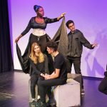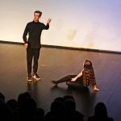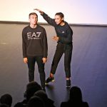
To rehearse and perform a Shakespeare play in just one day is quite the challenge…This hasn’t put us off! Bexhill College Acting students, in association with St Richard’s Catholic College teamed up with actor Milton Lopes and local primary schools to perform an original version of The Tempest.
The college students worked hard during the first term to put their scenes together, and the local primary schools have had workshops with Milton Lopes. The whole project came together when the primary schools visited the Izzard Theatre on 22nd and 23rd November to undertake a final day of workshops and rehearsals, culminating in a performance for parents at the end of the day. During the day the teachers were trained to deliver Explore and Discover Arts Awards.
The Schools Involved: Bexhill Sixth Form College, St Richard’s Catholic College, Bexhill High School, Little Common School, Chantry Community Primary School, St Mary Magdalen Catholic Primary School, St Peter & St Paul C of E Primary School, Etchingham C of E Primary School and Bodiam Church of England Primary School.
RSA Evidence Champions Network
The RSA has launched its new Evidence Champions Network that will connect cultural learning practitioners from across England who want to support better use of evidence and evaluation in their sector. You can find out more about how to get involved at;
https://www.thersa.org/discover/publications-and-articles/rsa-blogs/2018/05/evidence-champions-are-go
Teacher CPD and school development
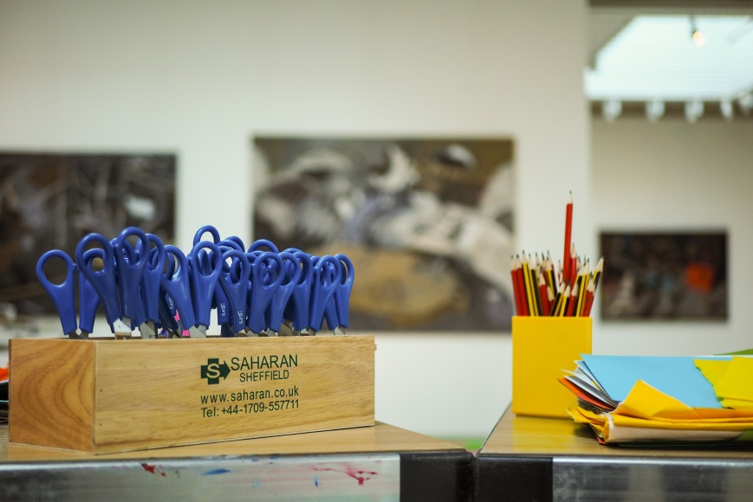
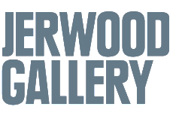
EVERYBODY IS AN ARTIST - CPD FOR PRIMARY SCHOOL TEACHERS
Monday 2nd July 2.30 – 6pm. Ticket Price: £20
This exclusive CPD opportunity for Primary School teachers will explore some of the ways to create effective and meaningful learning journeys for Art in the classroom.
The session is best suited to NQTs and teachers who are looking to boost their confidence in developing and delivering Art projects with a cross-curricular impact, or who would like to learn more about some of the ways in which we can ‘make time for art’ rather than simply ‘find time’. No matter what you think your skill level is, we will show you that all teachers are artists.
Join Skye Clarke, teacher and creative arts lead from Manorfield School and John Murray, Learning Manager from Jerwood Gallery, as we investigate some of the ways to plan and create exciting skills-based learning opportunities for students using the ‘teaching backwards’ pedagogy.
For more information, please contact John Murray on john@jerwoodgallery.or
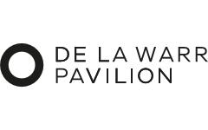
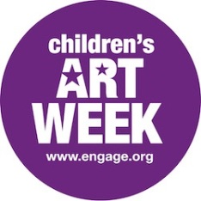
CHILDREN’S ART WEEK 2018
with De La Warr Pavilion
Monday 11 June – Friday 15 June
Book a FREE creative workshop in the galleries or your classroom. Actively engage with visual art through looking, discussing and making. Suitable for KS1 and KS2.

Workshops are limited and bookings taken on a first come first served basis.
To find out more and book a workshop email Grace.clements@dlwp.com or call 01424 229 103

Children’s Art Week 2016 is run by engage, the National Association for Gallery Education and supported by the National Association for Decorative and Fine Arts Societies (NADFAS), the Finnis Scott Foundation and the Garfield Weston Foundation. @engagevisualart #ChildrensArtWeek

Creative Boost
Creative Café for teachers: Thursday June 21 4.00-6.30pm De La Warr Pavilion, Bexhill
The Creative Café is an event that connects students in schools with employers. Through the Creative Boost programme over 200 young people from 12 schools in East Sussex have had the opportunity to meet people working across the creative industries. The response has been very positive with students valuing the opportunity to meet people and find out more about what’s involved in different creative roles.

On June 21 the Creative Boost programme offers a Creative Café for teachers. Set up as a Creative Café it will give you the chance to meet professionals working across the creative industries. It’s a chance to update your knowledge about working in the sector and to reflect on how better links can be made between schools and the sector, influencing teaching and learning and increasing young people’s awareness of potential careers.

Creative Boost is run by East Sussex County Council with the Towner Gallery supporting schools with the Arts Award and with Culture Shift running Creative Cafés.
To book a free place email creativeboost@eastsussex.gov.uk
Artsmark Celebration Event For Schools
Thursday 28 June 1-3pm at Lighthouse, Brighton
This summer, Artswork is hosting a celebration event to highlight the incredible work being carried out by Artsmark settings across the South East, and would be delighted if you could join us. This event will give teachers and pupils an opportunity to share how you are embedding arts and culture in your setting, and enable you to strengthen your Artsmark community network.
We will be joined by, Michael James Parker. Michael is host of Brighton’s Hammer and Tongue Poetry Slam, spearhead of the poets attack at the iconic Poets v MCs battles, leader of performance projects for young and old, an energetic stage performer and inspired campfire storyteller. He coaches poets and poetry in many different educational settings. Michael will be at the Lighthouse, facilitating a workshop and performing a spoken word piece written exclusively for Artsmark at the event.
Schools can book up to six free places, which can comprise staff and pupils. Places are limited so please book early. https://www.eventbrite.com/e/celebration-event-for-artsmark-settings-tickets-45130700139

Opportunities
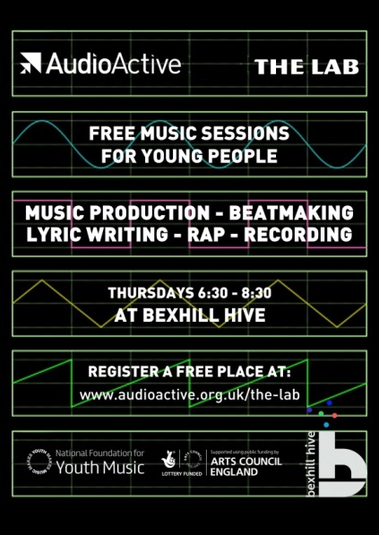
The Lab – FREE music workshops for young people at The Hive, Bexhill.
Beat making + lyric writing/rap workshops
Bexhill Hive, 41 St Leonards Road, Bexhill, East Sussex, TN40 1HS
The project is delivered by such esteemed artists as DJ Skitz (1Xtra) and rapper Jon Clark (Spoken Herd). The Lab family have created an acclaimed album featuring UK Legends Genesis Elijah & Jam Baxter
There are also regular opportunities to perform and AudioActive events across the county. Sign up at www.audioactive.org.uk/the-lab
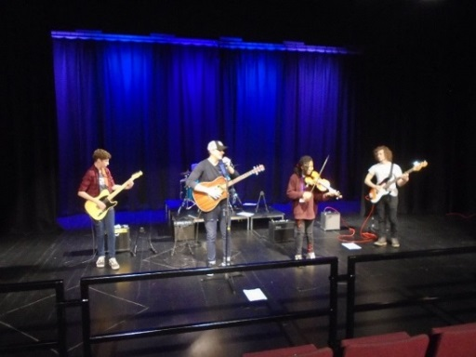
World Music Workshops
Bexhill College music students are busy devising a world music workshop ready to take out to local primary schools in the summer term. This is funded by the NHS Health inequalities funding. If you would be interested in having them into your school please contact us kieranmacfeeley@bexhillcollege.ac.uk

Glyndebourne Choral Summer School
The Choral Summer School is delivered by Glyndebourne as part of East Sussex Music’s Summer Schools programme and this year will be led for the first time by Glyndebourne’s renowned Vocal Talent Consultant Mary King and choral expert Travis Baker.
The course is for those aged between 13 and 18 and attending a school in East Sussex, it takes place at the Performing Arts Centre, Lewes from 16 – 20 July 2018. This year East Sussex Music has extended coach travel to Lewes; the coach will now depart from Hastings, Crowborough, Polegate and Uckfield for a small fee. Please see the application form for more details. Further information about the Summer School and how to apply can be found on East Sussex Music’s website: https://www.glyndebourne.com/education/take-part/young-talent-ages-9-30/glyndebourne-choral-summer-school
Opportunities from the South Downs National Park
South Downs National Park are reopening their Travel Grant programme on 23rd April. The Travel Grant allows schools to claim up to £300 towards travel costs when visiting any eligible education providers on the National Park Learning Map. For more information please see: https://learning.southdowns.gov.uk/learning/travel-grant/
Having been made an International Dark Sky Reserve in 2016, the South Downs National Park have also recently updated its Learning Zone and there are a lot of rich resources on there around heritage, the arts and creative learning as well as STEM and outdoor learning. https://learning.southdowns.gov.uk/
Participation Opportunities for St Leonards' schools (Years 7 & 8) at The SPACE
The SPACE, St Johns Road, St Leonards-on-Sea is a disused site owned by Network Rail & since 2013 has been used as a location for artists' temporary projects, performance & events. The projects run from April through October & have featured artists from Hastings, the South East region & mainland EU.
Outside the Walls is The SPACE's 2018 summer/autumn project featuring new work by artists from France, UK & the Netherlands. The three artists are Matthieu Husser, Tom Cardew & Yvo van der Vat. As part of The SPACE's work with the local community, we are offering opportunities for young people (& teachers) to meet with the artists, visit The SPACE to help create an installation &/or participate in an artist-led in-school workshop.
For more information please contact Christine Gist at: https://christinegist.wordpress.com/
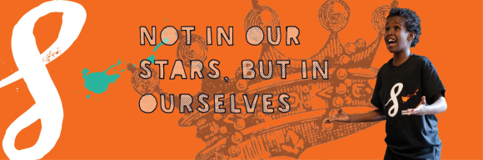
Shakespeare Schools Festival at White Rock Theatre
We would love to invite your school or youth drama group to take part in the 2018 Shakespeare Schools Festival and perform at the beautiful sea-front White Rock Theatre in Hastings this Autumn!
Every year the Shakespeare Schools Foundation puts on the UK's largest youth theatre Festival in over 150 theatres involving over 1000 schools. Our drama and literacy festival engages students in a way that promotes collaboration, teamwork, and improvement through perseverance. The Shakespeare Schools Festival process inspires our Teacher-Directors and their young people to take on the challenge with enthusiasm; to create an experiential and transformative learning process by taking risks and embracing failure as a way to progress. We will provide you and your students with all the training, resources and support you need to perform your own 30-minute abridged version of a Shakespeare play in a professional theatre alongside other local groups.
We would love to have you on board, so please do get in touch with Rach Skyer, our Outreach Officer for the South-East either by calling 0207 6011 823 or email rach@shakespeareschools.org.
Challenge and inspire your students through Shakespeare!
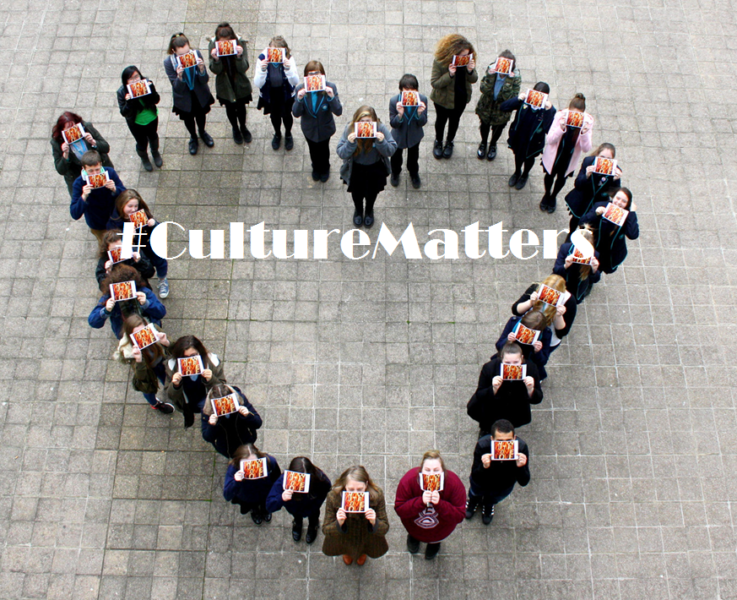

HRAEN is a voluntary organisation run by a steering group of representatives from schools, cultural organisations and local authority officers in Hastings and Rother. Our aim is to support schools in delivering high quality arts opportunities and to support students in their development and career paths.
If you would like to subscribe to HRAEN to receive email updates on new cultural events and opportunities please go to the website to submit your details : www.hraen.co.uk/subscribe

