Newsletter September 2017
News
This summer HRAEN has re branded, updated it website and is becoming a Charitable Incorporated Organisation in a drive to position ourselves at the heart of cultural education in Hastings and Rother.
Check out the website at: www.hraen.co.uk
Next Network Meeting: Tuesday 3rd October
The next HRAEN meeting will take place on Tuesday 3rd October at the White Rock Theatre Hastings from 4-6.30pm. This will have a literacy and drama focus with Niall Whitehead of ARK Helenswood discussing plans for developing the Royal Shakespeare Company associate schools programme, a programme designed to develop literacy skills for both primary and secondary pupils. For more information on the associate schools programme please go to the RSC website: www.rsc.org.uk/education/associate-schools-programme
Head teacher Becky Reed from Chantry Primary School will talk about her school’s Artsmark journey, what that entailed and why you should think about taking the plunge.
We hope to bring you our first TeachMeet session, short snippets from teachers and artists about recent projects and best practice. A model of sharing, networking and spreading the word. The lowdown on Teachmeet from Teacher Toolkit www.teachertoolkit.co.uk/category/teachmeets
And of course time for chat and meeting people and cake. Please let us know if you’ll be joining us - email melanie.powell@rother.gov.uk
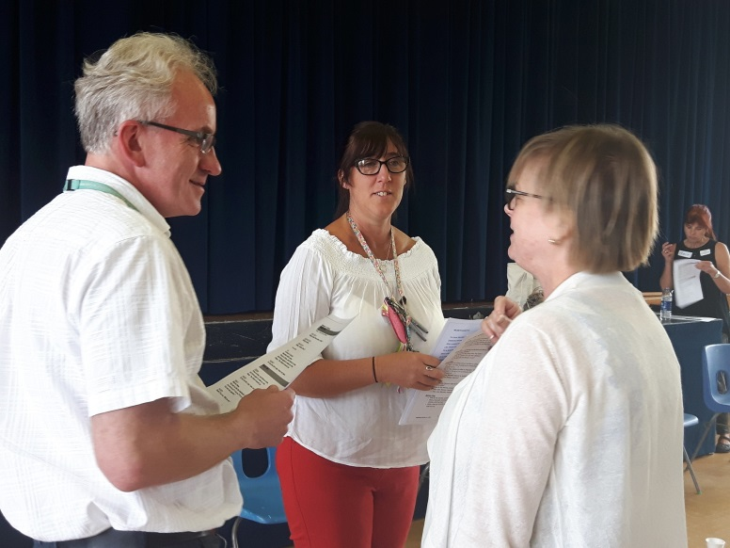
Teacher CPD and school development
LIVING LINES BIG DRAW FESTIVAL:
Celebrate the universal language of drawing with the De La Warr Pavilion. Fantastic FREE drawing sessions delivered in your classroom. Suitable for Key Stage 1, 2 or 3
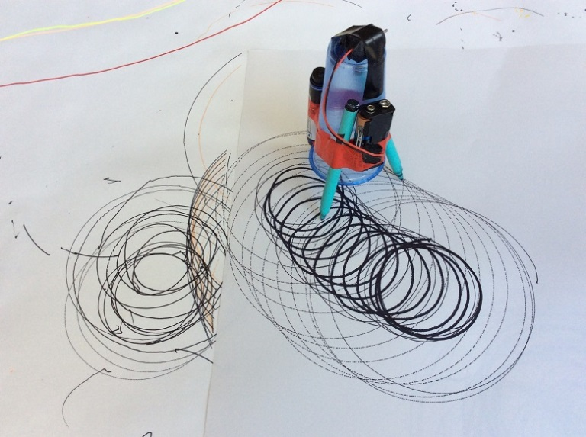
-90 minute sessions delivered in your classroom will explore STEAM curriculum links.
-Construct drawing robots and animate geometric shapes!
Thursday 5th October and Monday 16 October
FREE, available on a first come first serve basis
Book one or more sessions with ashley.mccormick@dlwp.com
https://www.dlwp.com/learning/schools/
'The Circle of Sita' from legend to life A Storytelling Workshop for Teachers
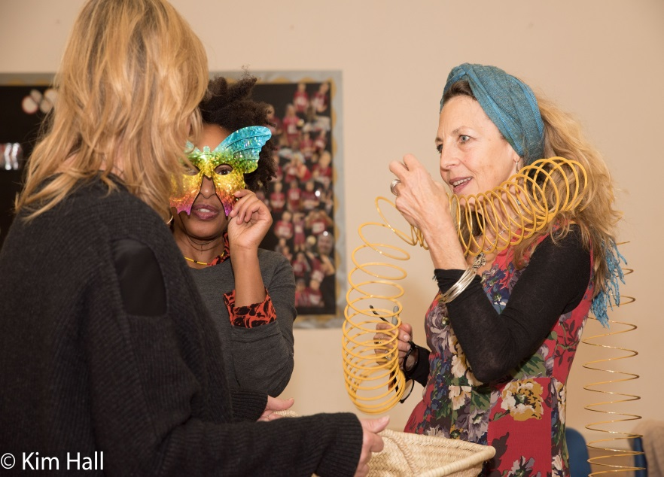
Hastings Storytelling Festival, produced by 18 Hours Events and Education presents a free CPD workshop with Louise Coigley.
The Storyteller and Speech and Language Therapist joins with 18 Hours to explore how storytelling techniques support literacy and help challenge social stereotypes. The workshop weaves threads from the traditional story of Rama and Sita, from The Ramayana, to explore how to inspire children to protect themselves and the planet. It draws on modern day social and environmental heroes and heroines from India to touch on personal and earth ecology.
1.30-4.30pm at Sandown School, TN34 2AA. The workshop is FREE but please book. For more information or to book, email office@18hours.org.uk

ARTSMARK – AUTUMN AND SPRING TERMS 2017/18
Schools in East Sussex have an incredible reputation for creativity and the relaunched Artsmark award is a great opportunity to demonstrate and recognise this in your setting. Awarded by Arts Council England, the new Artsmark award helps schools to deliver a high quality arts and cultural education.
www.artsmark.org.uk
Artsmark Development Days Autumn and Spring Terms 2017/18
- Wednesday 11th October 2017 Hastings, Jerwood Gallery
- Wednesday 7th February 2018 Hastings, Jerwood Gallery
The standard Artsmark package costs £500 (unless you are a small school with less than 100 pupils, which attracts a 50% discount).
- Artsmark has been designed by schools, for schools, to align with School Improvement Plans and support core EBACC and STEM priorities, giving the curriculum breadth and balance.
- As well as recognising schools that are making the arts come alive, the Artsmark award is a practical and valuable tool for enriching a school’s arts provision whatever the starting point.
- Artsmark has a common sense application process that is light on paperwork and flexible to each school. It provides schools with access to enviable networks of leading cultural organisations that will enable them to use the arts to engage and develop happy, self-expressed and confident young people and inspire teachers.
- Artsmark supports Arts Award which recognises the creative development of individual young people.
- Schools are awarded Silver, Gold or Platinum, based on their achievements.

Opportunities for students
Year 10 & 11 student open day and IAG opportunity
Dv8 Sussex has a brand new home at Bexhill Hive in the centre of Bexhill. The college offers vocational courses for 16 - 18 year olds in creative subject areas including Music Production & Performance, Media Production, Games Development and Fashion & Design at Level 1, 2 and 3. Students work in small class sizes (maximum 14 students) and are taught by industry professionals. For any young people interested in finding out more and progressing to us after GCSEs we have two open days coming up:
- Wednesday 11th October 6pm - 8pm
- Wednesday 15th November 6pm - 8pm
For further information please visit the college website dv8sussex.com on or call 01424 213890 / email apply@dv8sussex.com
Belongings: Glyndebourne Youth Opera
World premiere by Lewis Murphy
Date: Saturday 11 November at 3.00pm
Tickets: £10 (£5 concession)
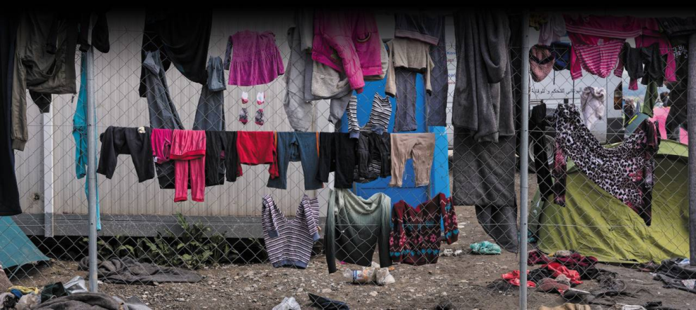
Belongings is a new commission by Lewis Murphy (Glyndebourne’s Young-Composer in Residence) and librettist Laura Attridge based on the theme of child migration performed by a chorus of young people in the local area and three professional soloists. It tracks the journeys of two groups of young people, divided by decades but united by the geographical displacement they experience.
Accompanied by their teacher, a group of evacuees board the train from London to Lewes to escape the Blitz, singing of the exciting adventure they anticipate in the countryside. Their optimism fades as they begin to pine for home, and one group decides to run away. Meanwhile, in the present day, a group of refugee children are re-building their recently demolished shelters. They try to remain positive while contemplating the dangerous final stage of their journeys.

Book now at www.glyndebourne.com/belongings or by calling the Box Office on 01273 815000

