Richard II Workshop
An introduction to the play / storytelling

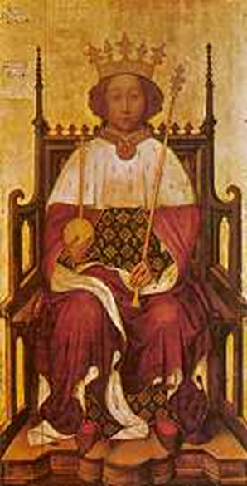
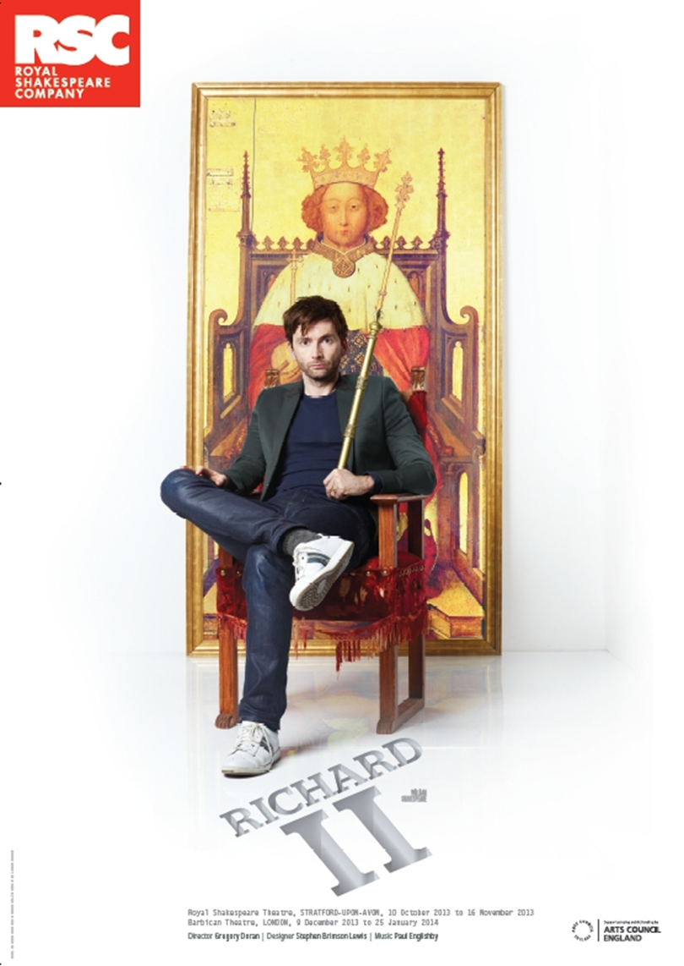

Introduction

THINGS KINGS HAVE DONE

The following is a list of things kings have done, in history and in Shakespeare plays.
Which is worst? Put them in order.

- Declaring war for no reason
- Arguing with your wife
- Drowning your brother in a barrel of wine
- Killing your brother’s young sons
- Having your subjects crushed to death
- Having your wife’s head chopped off
- Raising taxes for your people
- Spending too much money on yourself and your court
- Ignoring the poor
- Imprisoning your relatives for no reason
- Ordering the murder of your stepson
Which of these actions could you imagine modern leaders doing in the modern world?
Can you think of actions that modern leaders have done which would be high up on your list?
On Your Feet:
Groups create freezes with titles without talking
-A king and his court
- A good king and his court
- traitors plotting
- betrayal
- murder
How did the king get chosen in your pictures?
What was the difference between the freeze frames?

- In Medieval times people believed in Divine Right
This is the belief that kings were given the right to rule directly from God.
They didn’t have to answer to anyone except God.
It meant that some kings abused their power.
It also meant that rebellion was the worst of political crimes.

- In 1377 Richard is crowned King of England and Wales.
- He is only ten years old.
- Because he is so young the kingdom is ruled, at first, by his uncles:
- John of Gaunt
- Duke of York
- Duke of Gloucester
- As he grew older, Richard became angry at his lack of power and argued with his uncles.
- He took more power but did not spend the country’s money wisely.
- The Duke of Gloucester tried to limit his powers.
- When the play begins, somebody has just murdered the Duke of Gloucester.

- Who is responsible?

Look at the clues below to help you make your decision.

Clues List
JOHN OF GAUNT (To Richard): thou respect’st not spilling Edward’s blood
BOLINGBROKE: What dost thou know of noble Gloucester’s death, who wrought it with the king
BAGOT: Then set before my face the Lord Aumerle

FITZWATERS: I heard the banished (Mowbray) say that thou, Aumerle, didst send two of thy men to execute the noble duke at Calais
JOHN OF GAUNT: God’s substitute, His deputy anointed in his sight, hath caused (Gloucester’s) death
BOLINGBROKE: Mowbray...did plot the Duke of Gloucester’s death
MOWBRAY: For Gloucester’s death, I slew him not; but...neglected my sworn duty

Who killed the Duke of Gloucester?
Suspect Name | Reasons to Suspect them

Telling the story:
Allocate scenes to students and practise for performance.

Richard II.
A story of power and plotting
- The Duke of Gloucester is dead. A lavish funeral takes place.
In the presence of King Richard, Henry Bolingbroke accuses Thomas Mowbray (Duke of Norfolk) of stealing crown funds and of plotting the death of his uncle, the Duke of Gloucester.
Bilingbroke: Mowbray...thou art a traitor.
Mowbray: I do defy him and I spit at him
Call him a slanderous coward and a villain.

King Richard decides they should fight a duel to the death to decide who is telling the truth.

Richard: Be ready, as your lives shall answer it.

Q What would you want the audience to think about Richard’s character from this moment?

- The Duchess of Gloucester confronts John of Gaunt. She is angry about his lack of action against her husband’s killer (who Gaunt believes is the king!)

Duchess: ... cold cowardice! To safeguard thine own life
The best way is to avenge my Gloucester’s death.
Gaunt: Let heaven revenge, for I may never lift
An angry arm against his minister.

Q Why is John of Gaunt afraid to confront the king?

- Mowbray and Bolingbroke prepare to fight each other for honour, but at the last minute Richard stops them and decides instead to banish them both from England.

Richard: We banish you our territories.
Bolingbroke: Your will be done.
Mowbray: A heavy sentence, my most sovereign liege.
Bolingbroke is exiled for ten years (later reduced to six); Mowbray is exiled for life.
Q Why would Richard not want the fight to take place?

- John of Gaunt is dying. Richard is happy about this as he can take his lands and money for himself.
Richard: Now put it, God, in the physician’s mind
To help him to his grave immediately!

John of Gaunt begs Richard to let his son Bolingbroke return home. Richard refuses and Gaunt accuses him of being unfit to be king.

Gaunt: Landlord of England art thou now – not king
Richard: A lunatic lean-witted fool!

Q How would you maintain the audience’s sympathy for Richard after this scene?

- Bushy, Bagot and Green (The King’s followers) comfort the Queen who feels something is wrong now Richard has left for Ireland. Then York arrives to tell them that people are likely to rise up and fight with Bolingbroke, who has come back.
York: Gentlemen, go muster up your men.
Green: Well, I will for refuge straight to Bristol Castle.
Bagot: I will to Ireland.
Bushy: As York thrives to beat back Bolingbroke...

Q How would you develop tension in this moment?

- Bolingbroke, back from exile, and Northumberland (a supporter of Bolingbroke’s) meet with York on their campaign and he confronts Bolingbroke, his traitorous nephew.

Bolingbroke: My gracious uncle –
York: Tut, tut! Grace me no grace, nor uncle me no uncle. I am no traitor’s uncle.
Bolingbroke: My Father’s goods are all distrained and sold...what would you have me do?
York: It may be that I will go with you.

Q Why is York so easily persuaded to join Bolingbroke?

- Bolingbroke finds Richard’s followers, Bushy and Green, and has them brought before him to be sentenced before the King is even back in England.

Bushy: More welcome is the stroke of death to me
Than Bolingbroke to England
Green: My comfort is that heaven will take our souls
And plague injustice with the pains of hell
Bolingbroke: My Lord Northumberland, see them dispatched –

Q How would you use proxemics in this scene to show the emotions and status of each character?

- Richard arrives back in England from his fighting in Ireland with his followers, including York’s son Aumerle and Scroop, and despairs of the rebellion he has heard of.

King Richard: Say, is my Kingdom lost? Why, ‘twas my care,
And what loss is it to be rid of care?
Strives Bolingbroke to be as great as we?
Greater he shall not be.
Aumerle: Where is the duke my father, with his power?
Scroop: Your uncle York is joined with Bolingbroke

Q How would you use acting skills to demonstrate Aumerle’s inner thoughts at this moment?

- After negotiation Richard has returned to London and Bolingbroke summons Richard to parliament and asks him to hand over his crown in front of everyone.

Bolingbroke: Are you contented to resign the crown?
King Richard: With mine own tears I wash away my balm,
With mine own hands I give away my crown,
With my own tongue deny my sacred state,
With mine own breath release all duteous oaths

Q How would you direct the actor playing Richard at this key dramatic moment?

- York has just discovered his son, Aumerle, has tried to help Richard (who is now imprisoned) and is very angry at him but the Duchess of York appeals to Bolingbroke to forgive her son.

Duchess of York: O, happy vantage of a kneeling knee!
Yet I am sick for fear: speak it again,
Twice saying ‘pardon’ doth not pardon twain,
But makes one pardon strong.
Bolingbroke: I pardon him with all my heart.

Q Why is Bolingbroke showing compassion at this moment?

- In Pomfret Castle, where Richard is locked away, he questions his role in life now he is no longer a ‘king’ and is attacked by a group of men – Bolingbroke’s followers.

King Richard: (is stabbed)
That hand shall burn in never-quenching fire
That staggers thus my person...
Mount, mount, my soul! Thy seat is up on high,
Whilst my gross flesh sinks downward, here to die.
Dies

Q How would you avoid ‘over-acting’ the death of Richard?

- Bolingbroke has learnt of Richard’s death and is extremely upset. He never wanted Richard dead.

Bolingbroke: I thank thee not, for thou hast wrought
A deed of slaughter with thy fatal hand
Upon my head and all this famous land.

Q Why is Bolingbroke so angry that Richard has been killed and how do you convey this to the audience?

